**IOT LAB: 38**

**TASK 1: MAKE COS WAVE USING NUMPY AND MATPLOTLIB**

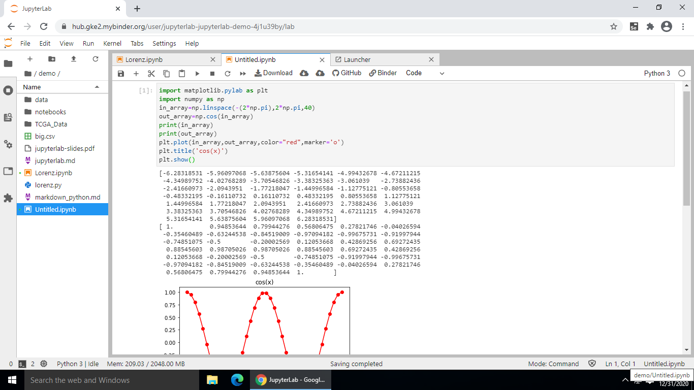

**OUTPUT:**

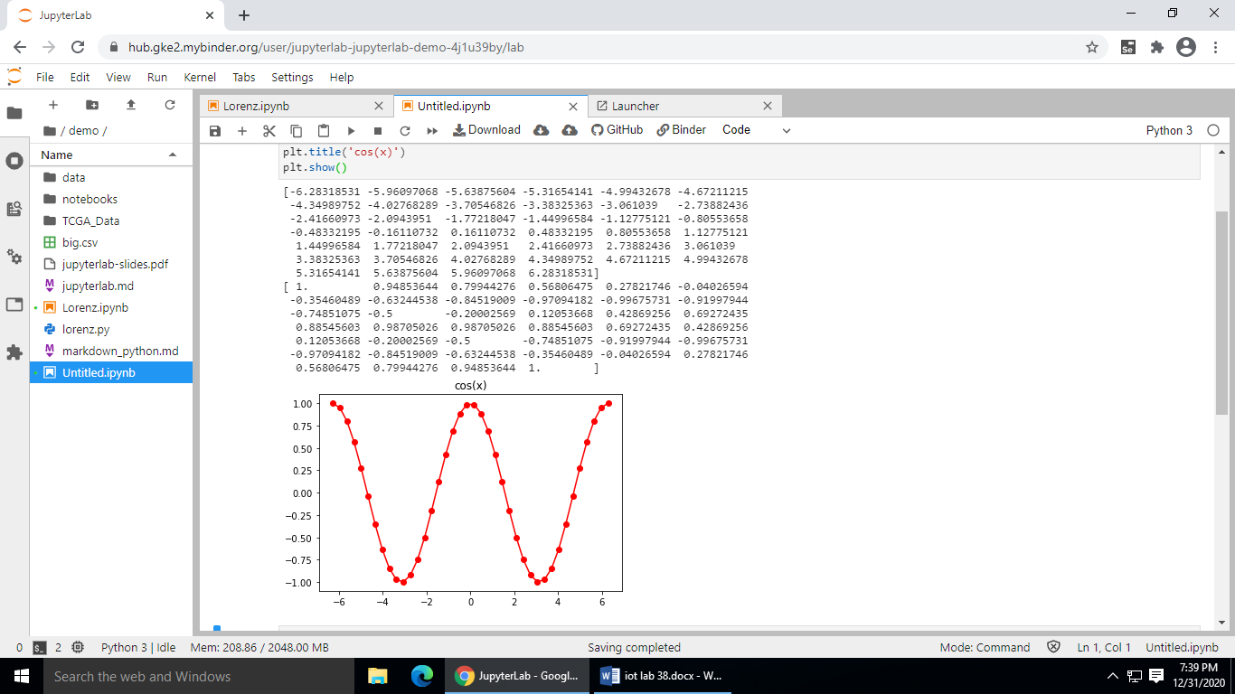

**TASK 2: READ CSV FILE**

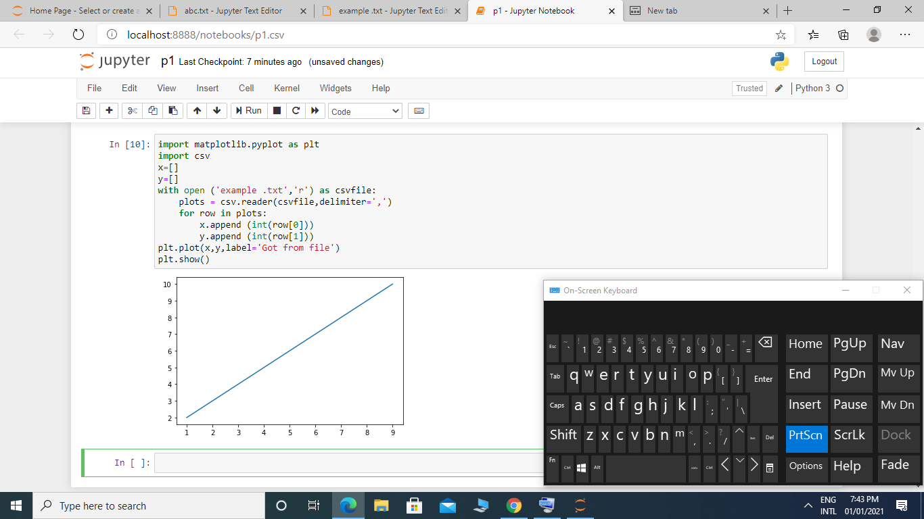

**OUTPUT:**



**TASK 3: ACCESS EXCEL SHEET USING PANDAS**

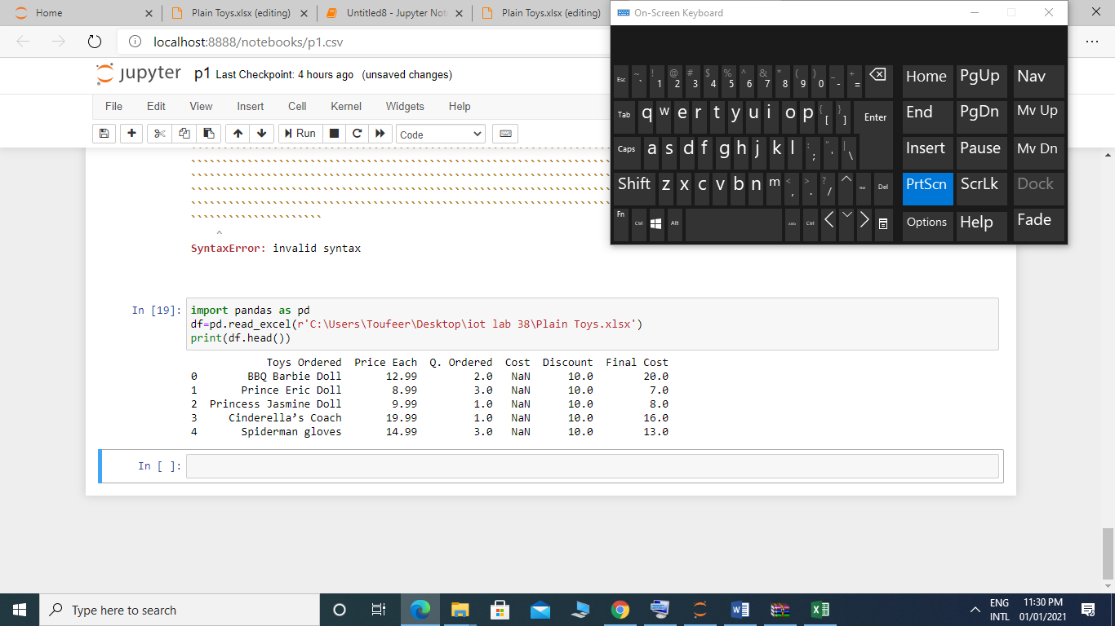

**OUTPUT:**



**TASK 4: ACCESS DATA OF EXCEL SHEET USING PANDAS**

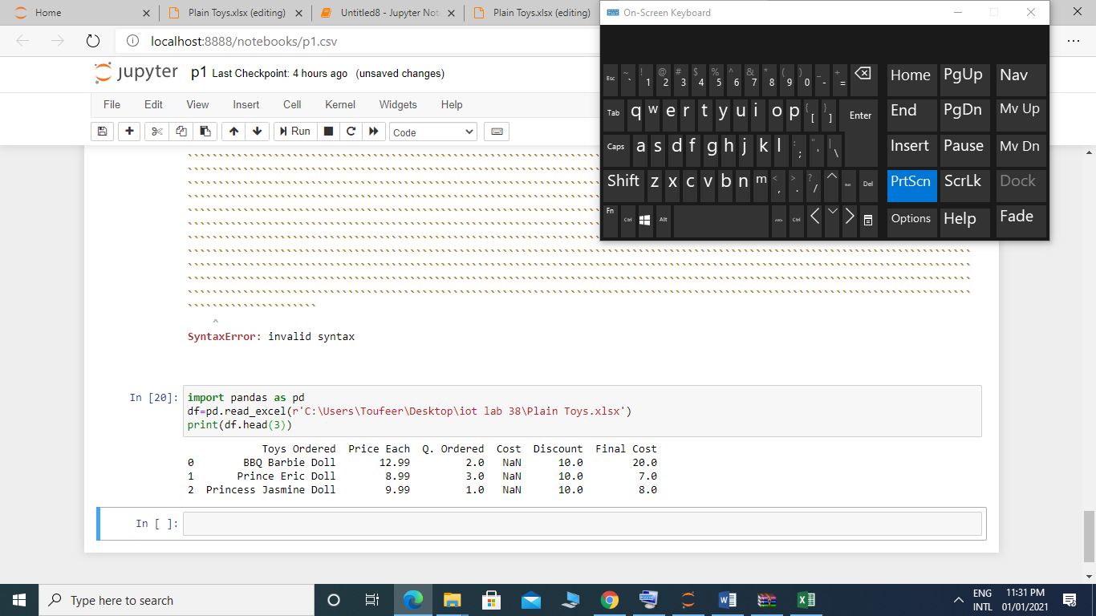

**OUTPUT:**



**TASK 5: CONVERT EXCEL TO CSV FILE**

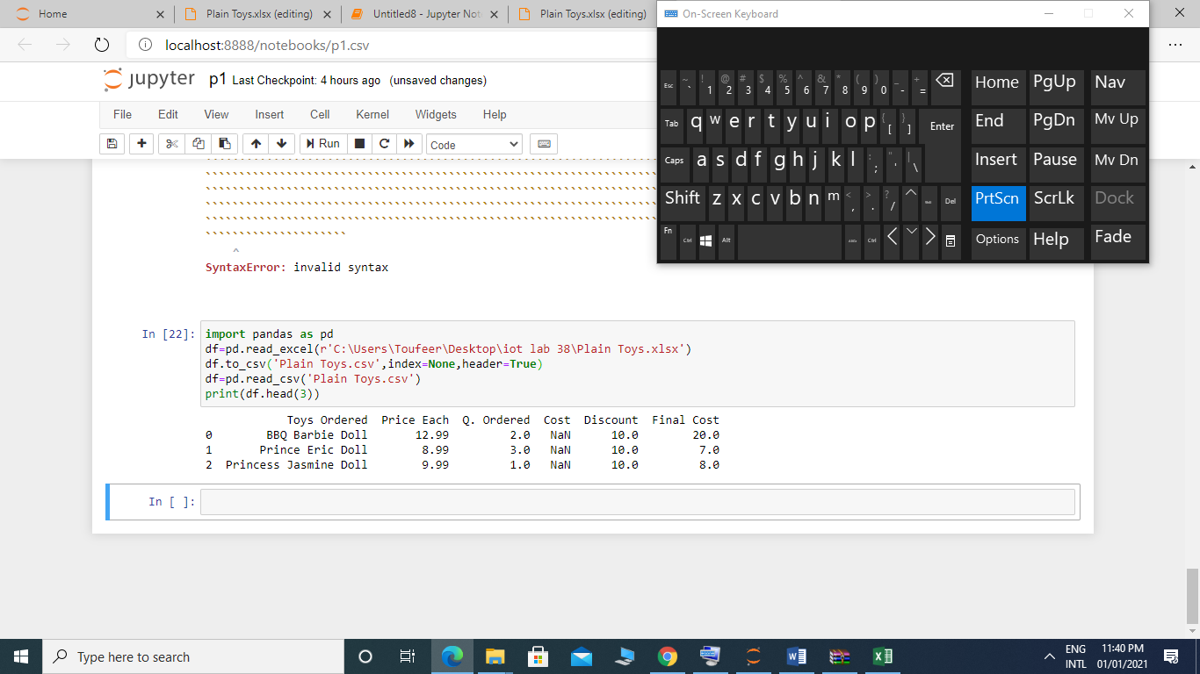

**OUTPUT:**



**TASK 6: ACCESS DATA OF CSV FILE**

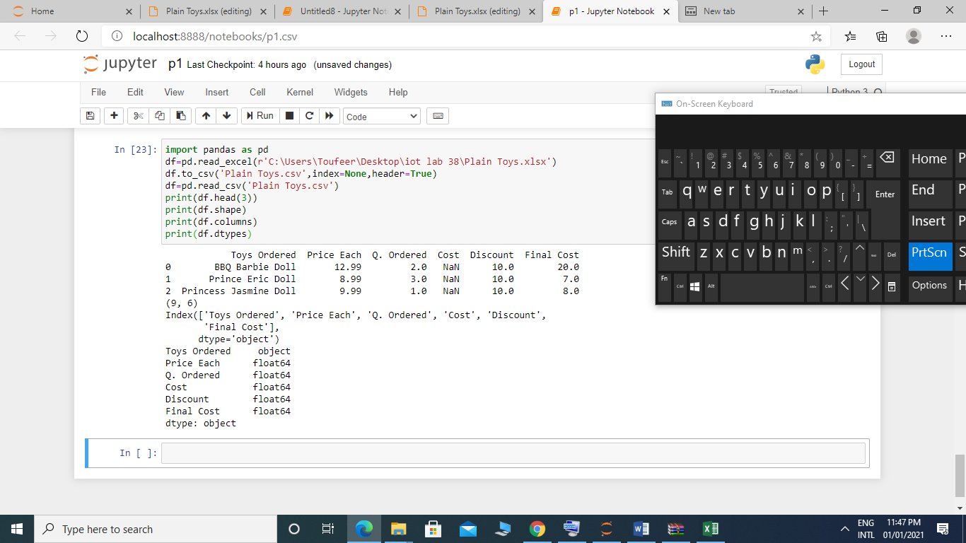

**OUTPUT:**

